Exno: 3

Date:

**DDL Commands with Constraints – PRIMARY, FOREIGN KEY, UNIQUE, CHECK**

**Aim:**

To create table employee, add with constraints- primary, foreignkey, uniqueand check using DDL commands.

1. **Create a table employee.**

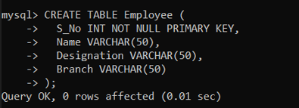

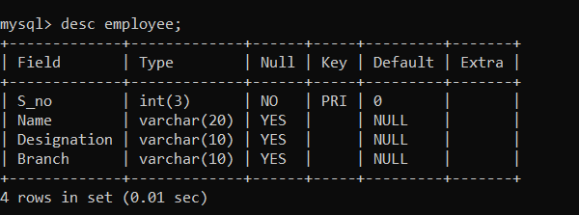

1. **S_no as primary key:**



1. **Create a tabe workers.**

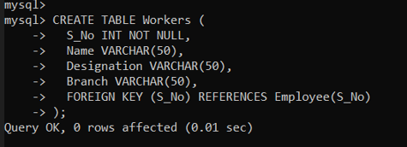

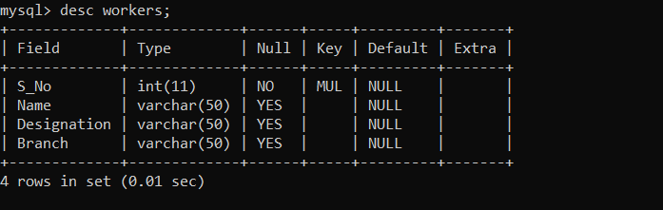

1. **S_no as foreign key:**



**Result:**

Tables are created, marked S_no as primary key, foreign key and checked the constraints.